LAB 7

Laboratory Report for CS 2420

Brent Johnson

Computer Science

Texas State University

Department of Computer Science

Bj1107@txstate.edu

*Abstract* –  This lab served as a crash-course in latches and flip-flops. Latches and flip-flops are important because they serve as the building blocks for all digital memory. Without memory, our digital devices would be practically useless, databases could not exist, and the modern computer would be impossible to implement.

# Introduction

The theme of this lab is memory. Memory is important because without long-term storage (or short term storage for that matter), modern hardware and software would not be possible. Variables in program memory could not exist. Arguments in program functions could not exist. Programs themselves could not exist because there would be no physical place to store the code for later execution.

In order to gain an understanding of memory, today’s lab involved the creation truth tables for sequential logic, diagrams with flip-flops, and diagrams using switches implemented with only nand gates.

# Experimental Method

I began the lab by constructing the following diagram in DSCH.

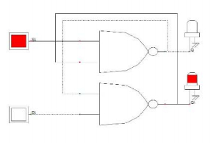

I then tested the results against expected results by populating a truth table with the results obtained by experimentation.

Next I created a SR latch with an enable button that activates or deactivates the input. I then used that schematic to test my predicted results against the obtained results from the experiment. Here is a copy of the diagram that I implemented.

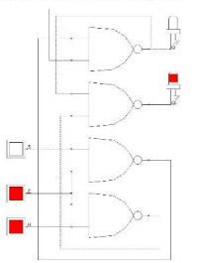

Next I created a D-latch with a pull-up resistor. I did the same procedure of comparing expected results against obtained results with the help of a truth table. Here is a diagram of the schematic I implemented.

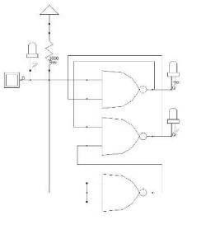

Finally, I created a circuit with flip flops. I created a schematic of the following diagram:

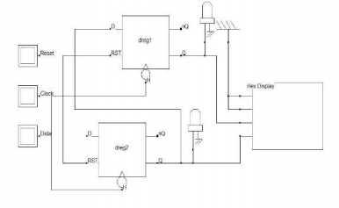

By attaching a hex display to two positive-edge triggered D flip-flops, I was able to implement a counter.

# Results

For the first part of this lab, I constructed a circuit from the provided diagram and filled in its respective truth values on a truth table. Here are the derived truth table results and the schematic:

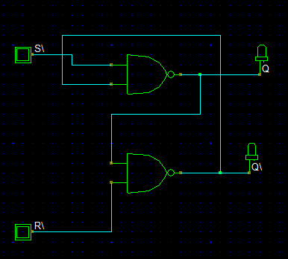

|  |  |  |  |  |  |
| --- | --- | --- | --- | --- | --- |
| Input | | Observed Output | | Predicted Output | |
| S\ | R\ | Q | Q\ | Q | Q\ |
| 1 | 0 | 0 | 1 | 0 | 1 |
| 1 | 1 | 0 | 1 | 0 | 1 |
| 0 | 1 | 1 | 0 | 1 | 0 |
| 1 | 1 | 1 | 0 | 1 | 1 |
| 1 | 0 | 0 | 1 | 0 | 1 |
| 0 | 0 | 1 | 1 | 1 | 1 |
| 0 | 1 | 1 | 0 | 0 | 0 |

As observed, some of my predicted outputs were incorrect. I did not have a complete understanding of the nature of flip flops and latches before the lab began. After receiving instruction during lab, I have a better understanding.

Next I created a circuit from a given diagram. This circuit was slightly different than the first because it has an enable switch that enables or disallows changes to the output when activated. I recorded the output results of the circuit in the following truth table.

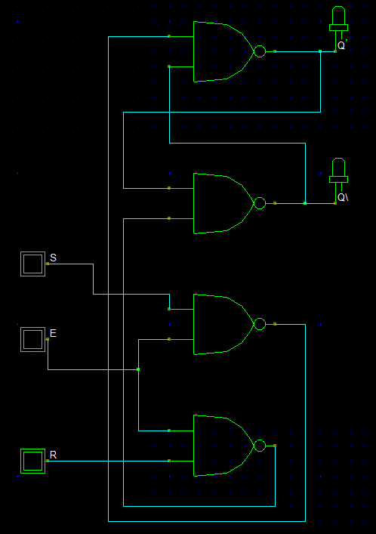

|  |  |  |  |  |  |  |
| --- | --- | --- | --- | --- | --- | --- |
| Input | | | Actual Output | | Expected Output | |
| E | S | R | Q | Q\ | Q | Q\ |
| 0 | 0 | 0 | 0 | 1 | 1 | 0 |
| 0 | 1 | 0 | 0 | 1 | 1 | 0 |
| 0 | 1 | 1 | 0 | 1 | 1 | 0 |
| 0 | 0 | 1 | 0 | 1 | 0 | 1 |
| 1 | 0 | 1 | 0 | 1 | 0 | 1 |
| 1 | 0 | 0 | 0 | 1 | 1 | 0 |
| 1 | 1 | 0 | 1 | 0 | 0 | 1 |
| 1 | 1 | 1 | 1 | 1 | 1 | 0 |
| 1 | 0 | 1 | 0 | 1 | 1 | 1 |
| 1 | 0 | 0 | 0 | 1 | 1 | 0 |

Once again, I was incorrect about my expected results due to a lack of understanding that has since been rectified.

Next I created a diagram of a D-latch with a pull-up resistor. Although DSCH does not represent sequential logic perfectly, I used DSCH to create this diagram. The results of the truth table are as follows.

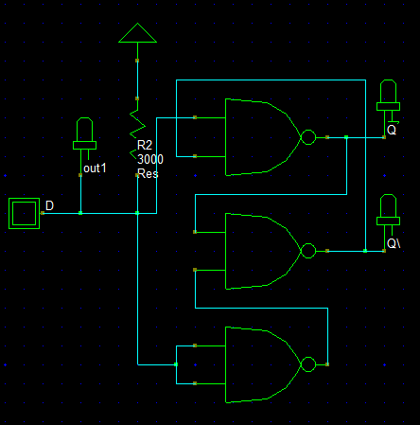

|  |  |  |  |  |
| --- | --- | --- | --- | --- |
| Input | Observed Output | | Expected Output | |
| D | Q | Q\ | Q | Q\ |
| 0 | 1 | 0 | 1 | 0 |
| 1 | 0 | 1 | 0 | 0 |
| 0 | 1 | 0 | 1 | 0 |
| Z | 0 | 1 | 1 | 1 |

The expected output was only included to demonstrate my previous ignorance.

Finally, I built a circuit with flip-flops using DSCH. I used D-positive edged trigger flipflops. This circuit was configured to act as a counter. The hex display in the circuit counts each time clock is triggered and data is also active. Here is a copy of my schematic.

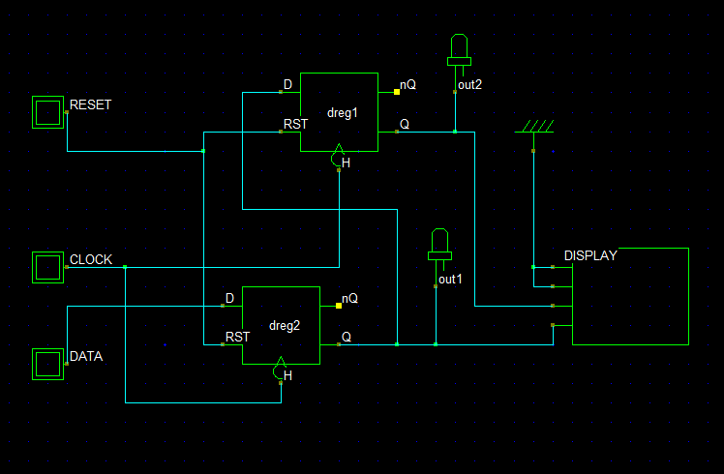

# Conclusion

Latches and flipflops are the foundational building-blocks of sequential logic. It is important to understand there underpinnings in order to utilize our digital resources most efficiently. There were several instances where my expected results varied widely from my actual results. This is because I was operating without detailed knowledge concerning sequential logic. This has since been corrected.